***CAR SALES PURCHASING***

**Name**: Arif khan

**Semester** : 7th sem

Rustamji Institute of Technology

B.S.F Academy Gwalior(M.P.)

**Duration: 2 weeks**

**Internship :** AI Engineer

#### Problem Statement: You are working as a car salesman and you would like to develop a model to predict the total amount that customers are willing to pay.

**Dataset:** Car_Purchasing_Data.csv

**It is contain following attributes like—**

Customer Name, Customer e-mail, 'Country, Gender, Age, AnnualSalary, Credit Card Debt, Net Worth**,** Car Purchase Amount.

**🡪** For Better prediction, I have to use the ANN Model(alg.) for car price predicton

*In these model I have also used tensorflow , relu functions and Dense layer.*

Dense layer is the regular deeply connected neural network layer. It is most common and frequently used layer.

**h = W*x + b**

**EXECUTION OF THE MODEL:**

**1.Import and load the dataset**

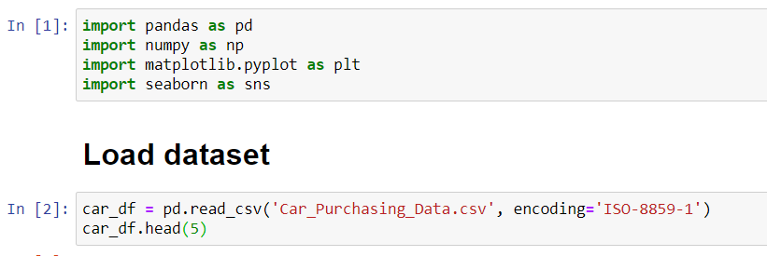

1. **Data visualization**

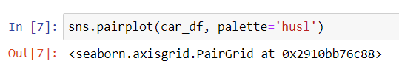

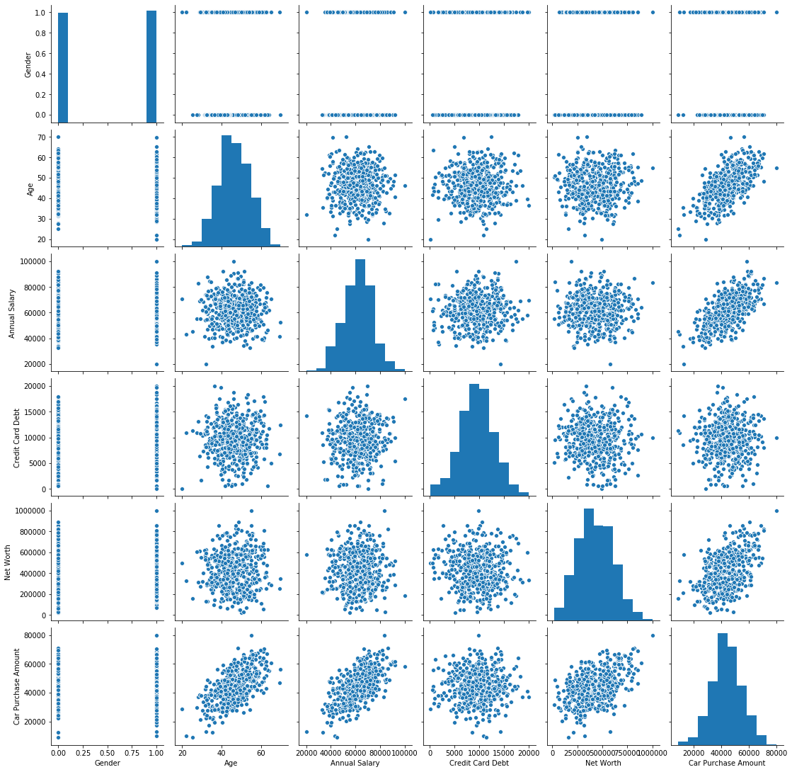

1. **Data cleaning**

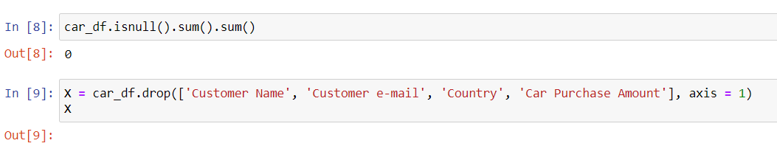

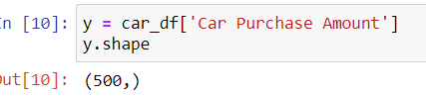

**Scaling and reshape the data:**

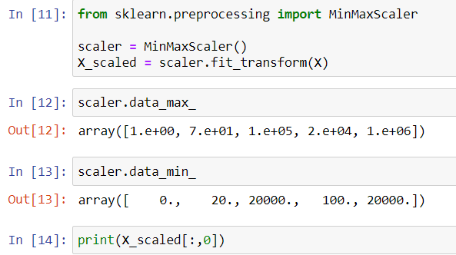

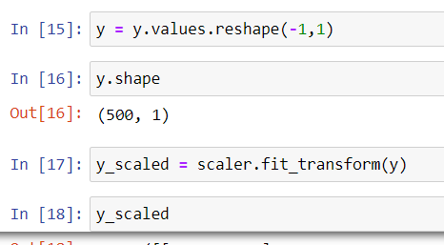

1. **Train the model:**



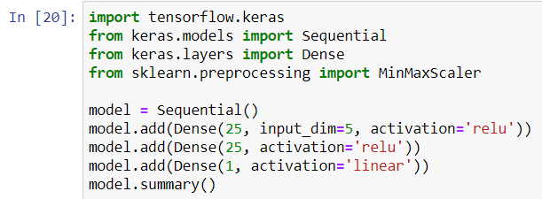

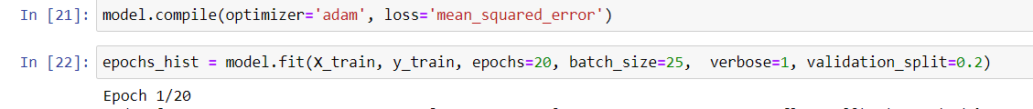

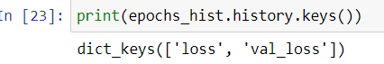

1. **Evaluate the model**

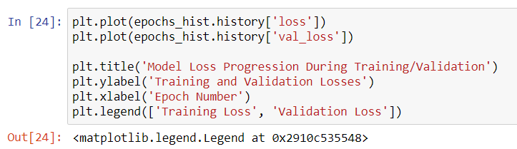

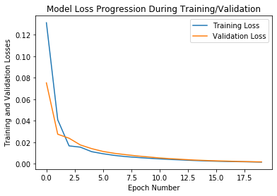

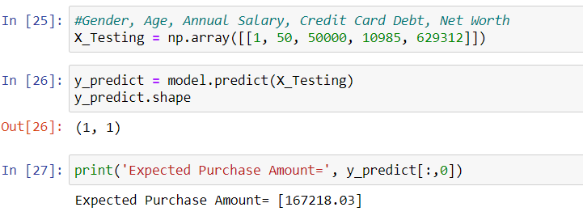

**Thanks:**



 